

PoW vs PoS –Consensus Mechanism Comparison
School:.............................................................................................................Campus:....................................................... AcademicYear:......................SubjectName:...........................................................SubjectCode:..........................
Semester:...............Program:........................................Branch:.........................Specialization:.......................... Date: .....................................
(Learning by Doing and Discovery)
* Coding Phase: Pseudo Code / Flow Chart / Algorithm
Introduction
The purpose of this experiment is to study and compare the two most common blockchain consensus mechanisms — Proof of Work (PoW) and Proof of Stake (PoS).
This comparison helps in understanding how blockchain networks achieve agreement on transactions, maintain security, and validate new blocks. The study will also highlight the differences in performance, energy consumption, and scalability between both mechanisms.

* Softwares used


- Chrome Web Browser
- Blockchain Explorers (e.g., Etherscan)
- Text Editor (VS Code / Notepad++)

Applied and Action Learning
* Implementation Phase: Final Output (no error

1. Proof of Work (PoW)
Proof of Work is a consensus method where miners use computing power to solve complex mathematical problems.
The miner who solves the puzzle first gets the right to add the next block to the blockchain and earns a reward for doing so.
2. Proof of Stake (PoS)
Proof of Stake is a consensus mechanism in which validators are chosen based on the number of coins they stake (lock) in the network.
Instead of mining, selected validators verify transactions and create new blocks.
This approach is much more energy-efficient and enables faster confirmation of transactions.

Here are rewritten versions with the same meaning:

1. Proof of Work (PoW)
Proof of Work is a consensus method where miners use computing power to solve complex mathematical problems.
The miner who solves the puzzle first gets the right to add the next block to the blockchain and earns a reward for doing so.
Although this method provides strong network security, it requires a large amount of energy and processing power.
2. Proof of Stake (PoS)
Proof of Stake is a consensus mechanism in which validators are chosen based on the number of coins they stake (lock) in the network.
Instead of mining, selected validators verify transactions and create new blocks.
This approach is much more energy-efficient and enables faster confirmation of transactions.

- Working Steps of PoW
4. Working Steps of PoS
- Mining: Miners compete to solve a mathematical puzzle.
- Nonce Finding: Each miner tries different nonce values to achieve a hash below the target difficulty.
- Block Validation: The first miner who finds a valid hash broadcasts the block. Other nodes verify and add it to the chain.

• Choosing Validators:
Validators are picked in a random manner, influenced by how many coins they have staked.
• Block Creation:
The selected validator creates and submits a new block to the network.
• Verification and Confirmation:
Other validators review the proposed block, and once it is confirmed, it is permanently added to the blockchain.

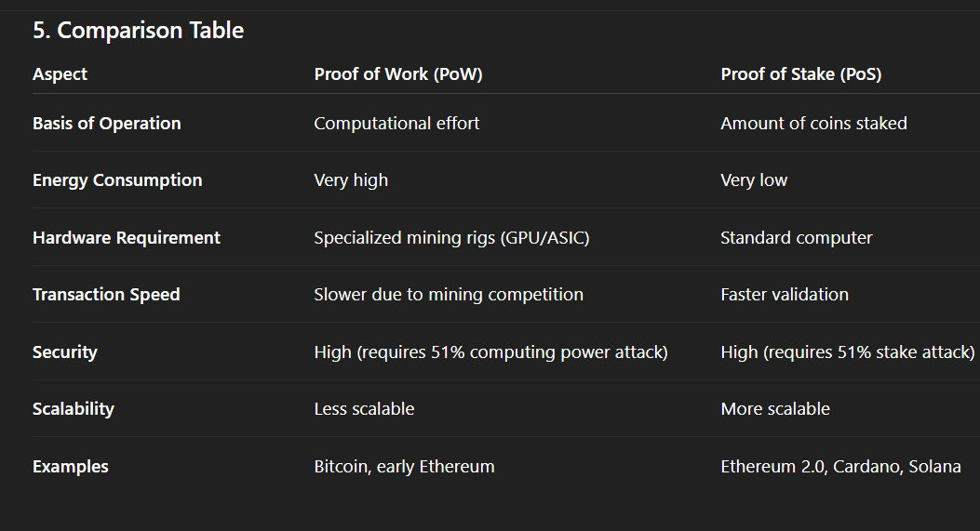

* Implementation Phase: Final Output (no error) Applied and Action Learning

- Proof of Work (PoW) relies on high computing power to validate transactions.
- It ensures strong security but requires a large amount of energy.
- Proof of Stake (PoS) chooses validators according to the number of coins they have locked (staked).
- It operates with lower energy usage, offers faster processing, and is more eco-friendly.
Therefore, although both methods help blockchains reach consensus, PoS is considered more efficient and sustainable for current and future blockchain networks.

* Observations
It was seen that Proof of Work (PoW) offers strong security because of its complex computation requirements, but it requires considerable time and energy.
On the other hand, Proof of Stake (PoS) is more energy-efficient and faster while still offering reliable security.

Rubrics
Concept | 10
Planning and Execution/  Practical Simulation/ Programming | 10
Result and Interpretation | 10
Record of Applied and Action Learning | 10
Viva | 10
Total | 50


Signature of the Student:
Signature of the Faculty:

